Laboratorio_Semana3.R

Usuario1

2024-08-29

#Laboratorio semana 3   
# 30/08/2024  
#Francisco Javier Herrera Nevarez   
#Matricula: 2019566  
  
#IMPORTAR DATOS DE TRABAJO------------------------------------------------------------------------  
tabla <- read.csv("C:/Repositorios_FJHN/Met_Est_2024/Clase/DATOS.csv", header = TRUE)  
head(tabla)

## Arbol Fecha Especie Posicion Vecinos Diametro Altura  
## 1 1 12 F C 4 15.3 14.78  
## 2 2 12 F D 3 17.8 17.07  
## 3 3 9 C D 5 18.2 18.28  
## 4 4 9 H S 4 9.7 8.79  
## 5 5 7 H I 6 10.8 10.18  
## 6 6 10 C I 3 14.1 14.90

#Seleccion de datos-------------------------------------------------------------------------------  
  
# Aplicar la función subset para la variable Altura-----------------------------------------------  
H.media <- which(tabla$Altura <16.5)  
H.media

## [1] 1 4 5 6 7 9 10 13 14 15 16 17 20 21 22 24 25 26 27 28 29 30 31 32 34  
## [26] 35 36 38 39 40 41 42 43 44 45 46 47 48 50

mean(tabla$Altura)

## [1] 13.9432

H.Media <- which(tabla$Altura <= mean(tabla$Altura))   
H.Media

## [1] 4 5 14 15 16 20 21 22 26 27 30 31 32 35 38 39 40 41 43 44 45 46 47 48

H.Media <- which(tabla$Altura>18.5)  
H.Media

## [1] 18 23

# Aplicar la función subset para la variable Vecinos-----------------------------------------------  
Vecinos.3 <- which(tabla$Vecinos<=3)  
Vecinos.3

## [1] 2 6 7 8 11 13 14 16 17 18 20 23 25 27 28 29 30 31 36 37 38 41 42 46 49  
## [26] 50

Vecinos.4 <- which(tabla$Vecinos>4)  
Vecinos.4

## [1] 3 5 10 12 21 32 34 40 44 47 48

# Aplicar la función subset para la variable Diametro---------------------------------------------  
mean(tabla$Diametro)

## [1] 15.794

DBH.media <- which(tabla$Diametro<mean(tabla$Diametro))  
DBH.media

## [1] 1 4 5 6 11 12 16 19 21 24 28 31 32 33 34 35 39 40 41 42 44 45 46 47 48

DBH.16 <- which(tabla$Diametro>16)  
DBH.16

## [1] 2 3 7 8 9 10 13 14 15 17 18 20 22 23 25 27 29 30 36 37 38 43 49 50

DBH.16 <- which(tabla$Diametro<=16.9)  
DBH.16

## [1] 1 4 5 6 10 11 12 14 16 19 21 22 24 26 27 28 31 32 33 34 35 39 40 41 42  
## [26] 43 44 45 46 47 48

# Histogramas-------------------------------------------------------------------------------------  
hist(tabla$Altura, col = "lightblue")

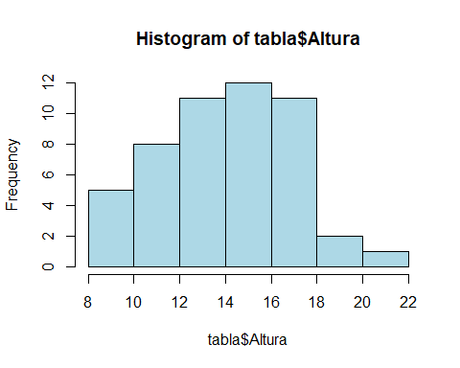

hist(H.media, col = "lightgreen")

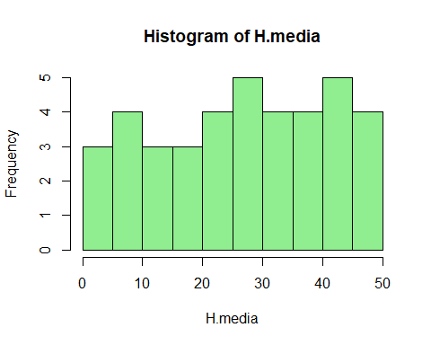

hist(H.Media, col = "lightyellow")

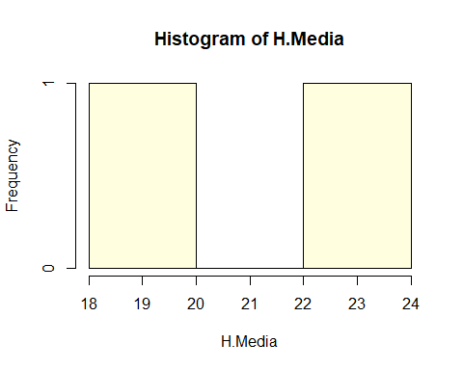

hist(tabla$Vecinos, col = "lightpink")

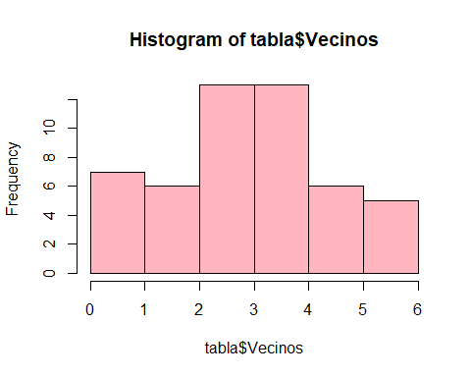

hist(Vecinos.3, col = "blue")

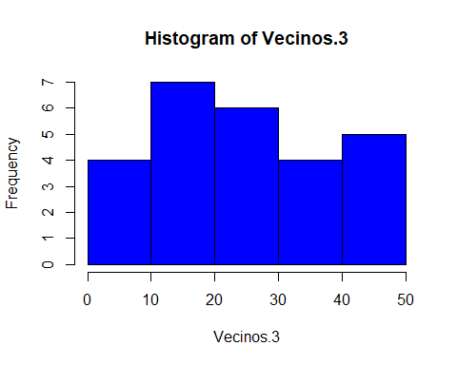

hist(Vecinos.4, col = "green")

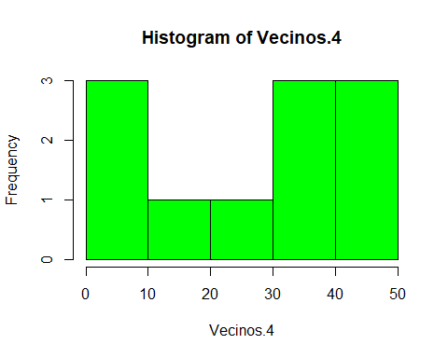

hist(tabla$Diametro, col = "yellow")

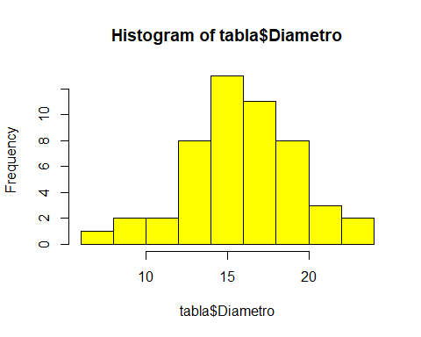

hist(DBH.media, col = "orange")

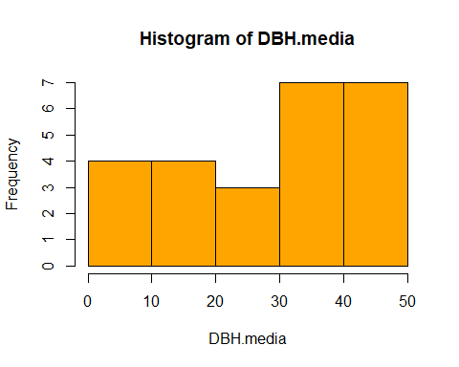

hist(DBH.16, col = "purple")

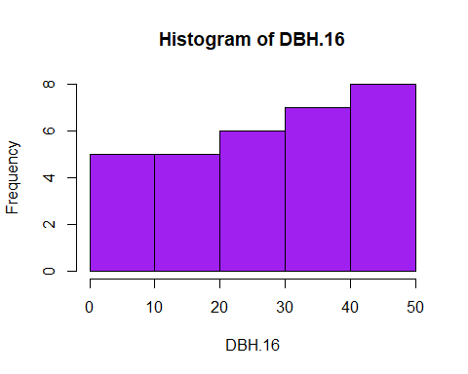

# Determinar la media-------------------------------------------------------------------------------  
mean(tabla$Altura)

## [1] 13.9432

mean(H.media)

## [1] 27.17949

mean(H.Media)

## [1] 20.5

mean(tabla$Vecinos)

## [1] 3.34

mean(Vecinos.3)

## [1] 25.53846

mean(Vecinos.4)

## [1] 26.90909

mean(tabla$Diametro)

## [1] 15.794

mean(DBH.media)

## [1] 28.16

mean(DBH.16)

## [1] 27.29032